(Basics of Numpy Array)

Name: Anuj Solanki

Register No: 20218411

Q.1. create two arrays with following values:

First = 9 8 7

6 5 4

3 2 1

second = 11 2 44

53 7 55

34 90 67

Perform following operations using both the arrays:

a. Display the sum of columns for First Array.

b. Display the sum of rows for Second Array

c. Display a new array with all minimum values present in both arrays.

Code

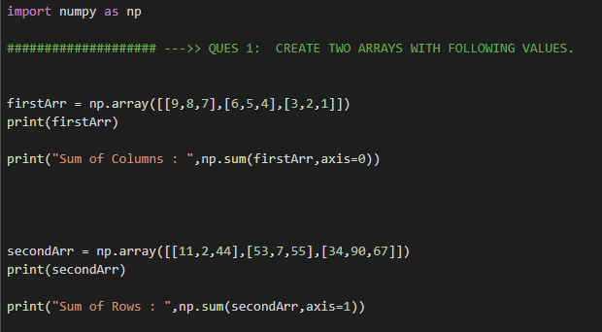

Output:

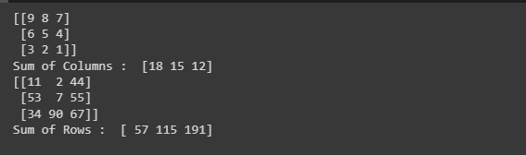

Q.2. Explain the following functions using suitable examples.

a. min

b. zeros

c. eye

d. ones

e. argmax

Code:

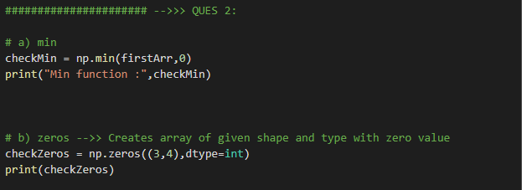

Output:

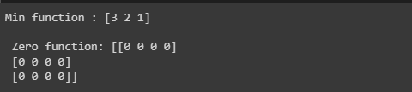

Q.3. Create an array containing values in the range of 50 to 100. From this array display the numbers that are divisible by 7.

Code:

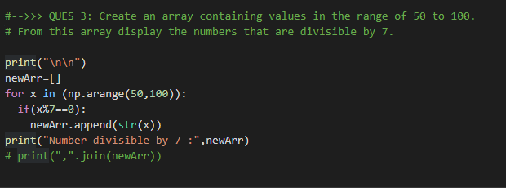

Output: 